ALW EARTHLINK
SEPTEMBER 2023

In this issue…..
School’s IN!
Pow Wow Honoring Veterans
Empower an Engineer
Christmas Giving Project – Gift them with Games!
A special thank you
Environmental News
And finally…..

School’s IN!
The school busses are rolling, the backpacks are full, the fall sports have started – it’s school time!
We made a very special trip to Kentucky with a VERY full carload of school supplies, clothing, gift cards, snacks and other surprises for the 26 students in the “Empower an Engineer” program. The families and individuals who are sponsoring them were quite generous, and there were smiles all around as the backpacks and tote bags were handed out. Thanks to each and every one of you who is committed to this program for the entire school year!
Pow Wow
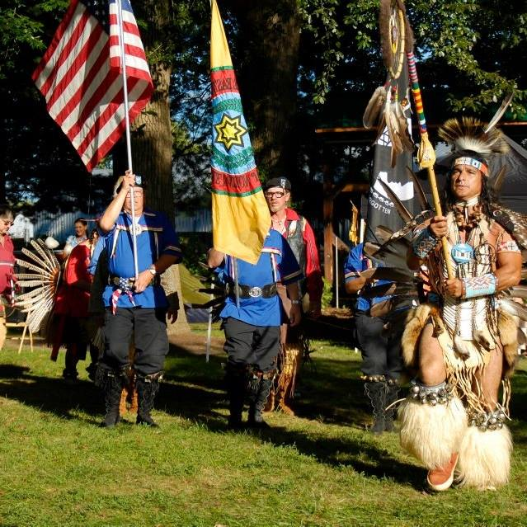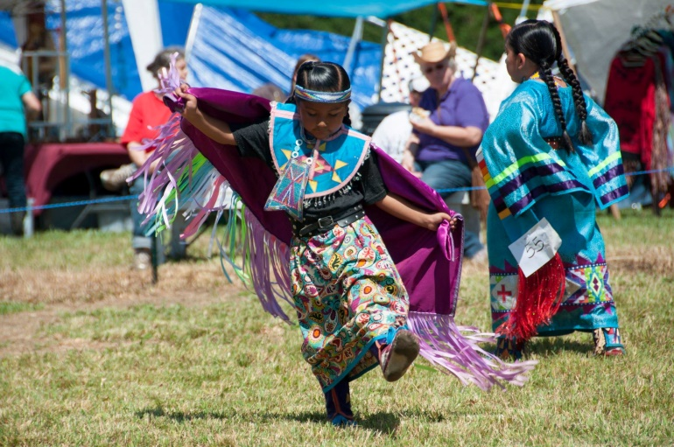

If you have never been to a Native American Pow Wow and if you are free Labor Day weekend, come on down to Corbin, Kentucky! We will meet you at the gate (we are the official gate keepers!), but the rest of the day (or two) will be filled with education, dancing, drumming, arts, crafts, traditional Native American food (mmmm, fry bread!), and more! Free admission is given to all veterans, and they are celebrated in a unique way. This year’s event is extra special, because we will be honoring the late Ken Phillips on whose land the Pow Wow has been held for years. Ken was instrumental in bringing awareness of Native American heritage to his home state of Kentucky. He was a long-time friend of ours and he taught us and our Camp H.O.P.E. participants so much about the Native American culture!
We’d love to see you there!
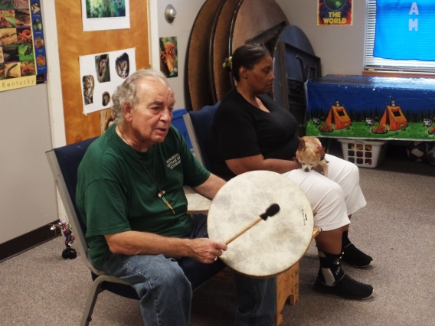
Ken drumming for our Camp H.O.P.E. kids
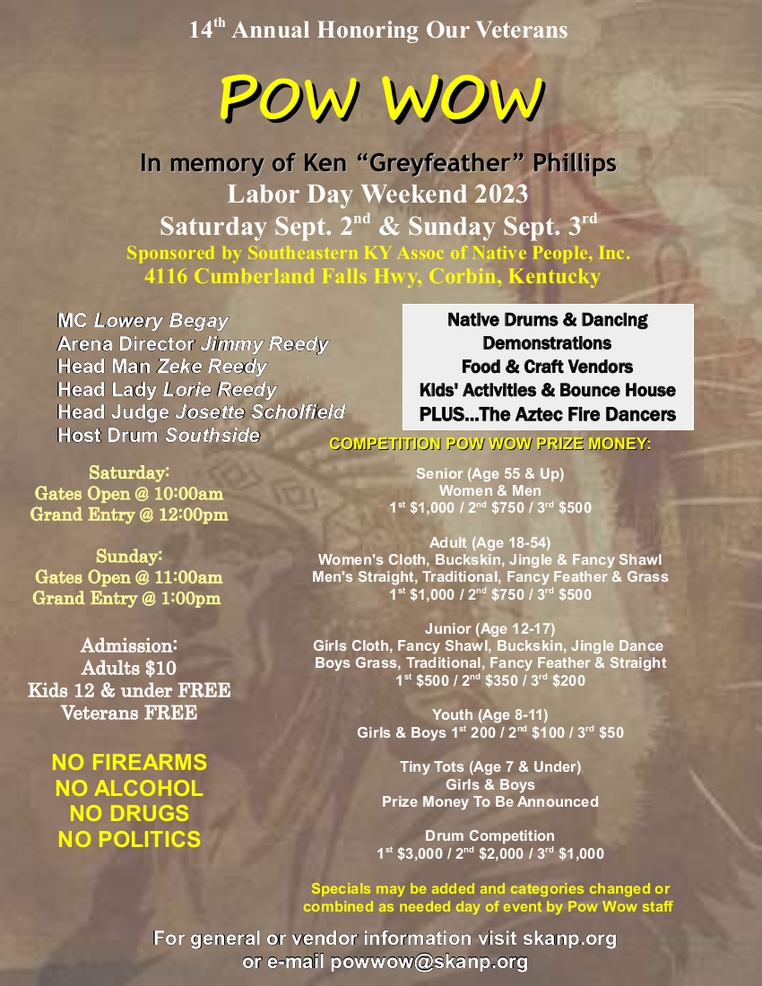

Empower an Engineer
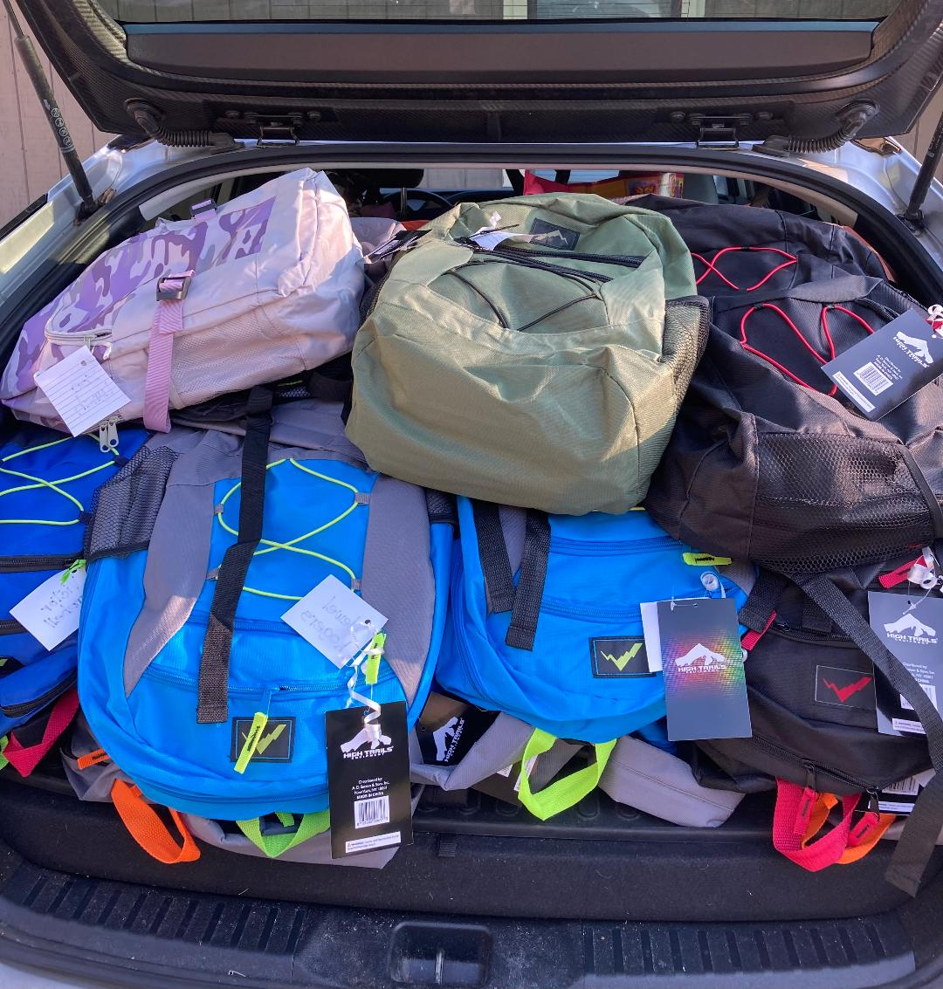
26 backpacks full of school supplies!

Our year-long project is off to a GREAT start! Thanks to our sponsors, we were able to deliver FULL backpacks with every school supply each child needed, plus a few after-school snacks that the kids told us were their favorites. And then – the sponsors gifted each student with 3 new back-to-school outfits, undwear, socks, toiletries, gift cards and birthday gifts for the August/September birthday celebrants! WOW!
Our school liasion, Mr. Mike Flynn, was (in his own words) like ‘a kid in a candy store!’ when he helped us bring in all the treasures. He guaranteed us that each child recipient would feel like Christmas came early this year! Thanks to EVERY ONE OF YOU who helped make this happen! I’m crying happy tears here!
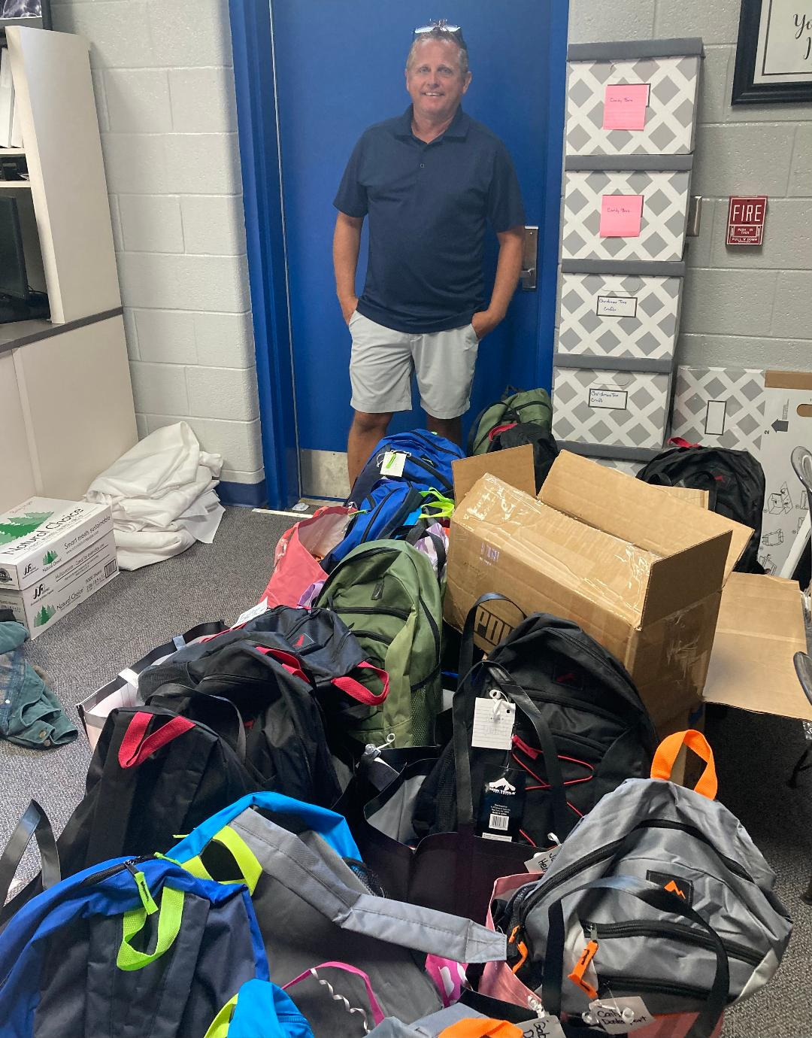
Mike as we started to bring in the backpacks and bags!

Christmas Giving Project – Give them with Games!
As you can tell, the families and individuals who have already donated very generously to their sponsored student cannot be asked to do more! This year, our annual Christmas Giving Project will be to gift each of our sponsored students with a board game or two! The students gave us a ‘wish list’ of games they do not own but would like to have. We are hoping to provide at least 2 games to each child. This is a great way for you to participate in this program without making the full commitment to sponsor a student for the entire year. The school assures us that the children are truly in need and won’t find much under their holiday trees without our help.
Want to gift a game? You can send me a check made out to A Lasting World Inc., you can use Paypal to send a donation (alastingworld@sbcglobal.net), or you can go to Amazon and look up the gift registry under my name (Wendy Marcec) and pick out the game you’d like to have shipped to me! I will need all donations no later than September 30 so that we have time to sort, wrap and deliver before the students’ Christmas break.
Thanks for considering being a part of this project – and a HUGE thank you to the generous people who have already made a contribution! Bless you all!

A special thank you
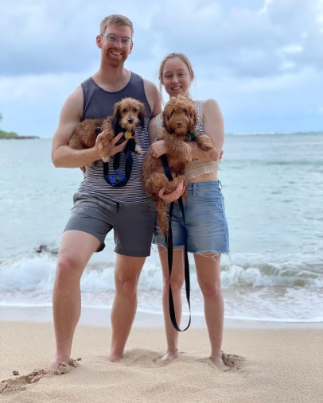
I will, of course, be thanking EVERY ONE of you who have sponsored a student or who have made a donation to the Christmas Giving Project….but there is one person I must single out and brag about!
This is Natascha. She attended Camp H.O.P.E. (so did all her siblings in later years!) and was remarkable then --- but she is absolutely amazing now! She has a wonderful success story! She graduated from medical school, she is serving her country as a physician, she is happily married, she is busy with many things – AND she just made a very sizable donation to our Christmas Giving Project! I am so overwhelmed by her kindness! We are blessed to know such a beautiful young woman who pays it forward and who deeply cares about others. Thank you, Natascha! Best of luck in all you do! We’ll be cheering you on!
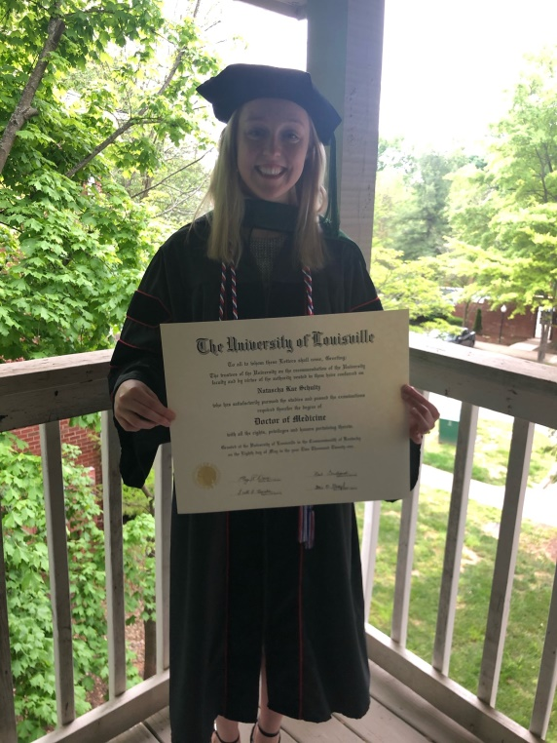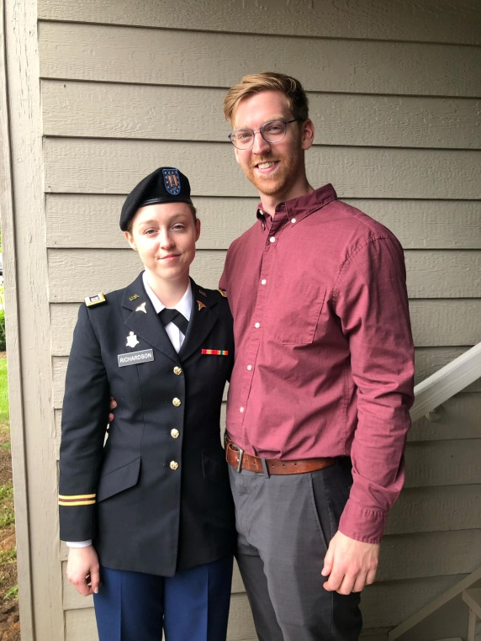

Environmental News
Plant for the Planet
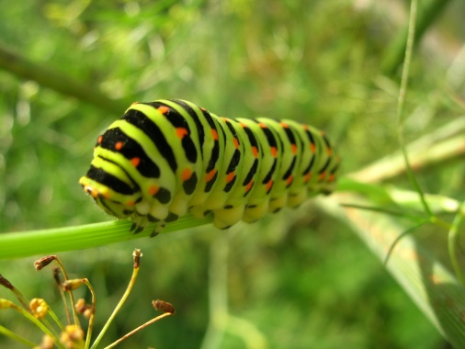
Gardening for wildlife has never been easier, thanks to the National Wildlife Federation’s (NWF) native plant collections – sustainably grown plants that benefit birds, pollinators and other wildlife. Native to your region, the plants ship right to your door with planting tips from gardening experts. The NWF currently offers plants in 38 states and will soon be expanding nationwide. To order, visit www.gardenforwildlife.com/mag. Use code NWFMAG23 to save 10%! (National Wildlife Federation)
Simple nests breed success
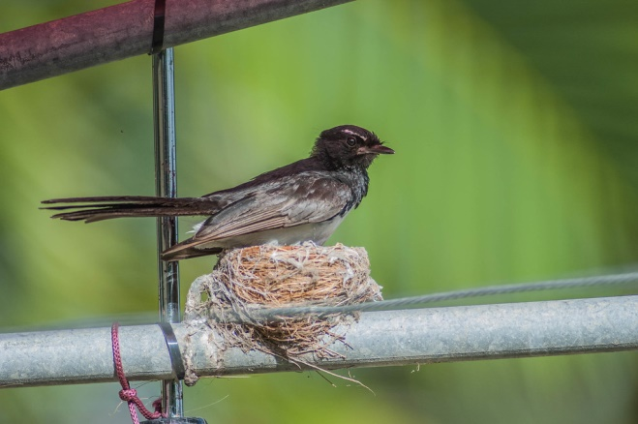
About 1/3 of the planet’s roughly 11,000 bird species build elaborate domed nests with roofs that would appear to provide better protection for eggs and hatchlings than open nests. But according to a recent study by Australian biologists, just the opposite seems to be the case. In an analysis of physiological and geographical data for more than 3,100 songbird species worldwide, the scientists conclude that birds that build simpler, cup-shaped nests may be more adaptable to changing habitat and climatic conditions. “Our results support the idea that nest types can be important factors in the ecological success of birds,” writes lead author Iliana Medina in Ecology Letters. An evolutionary biologist at the University of Melbourne, Medina explains that domed nests require more time and materials to build, and their large size can attract predators. The scientists write that species with open nests “have larger ranges with broader thermal niches and are more likely to colonize urban environments.” They also, Medina adds, tend to have lower extinction rates than species that build domed nests. (Mark Wexler)

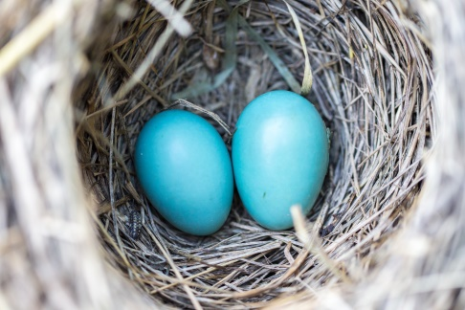
Freshwater riches
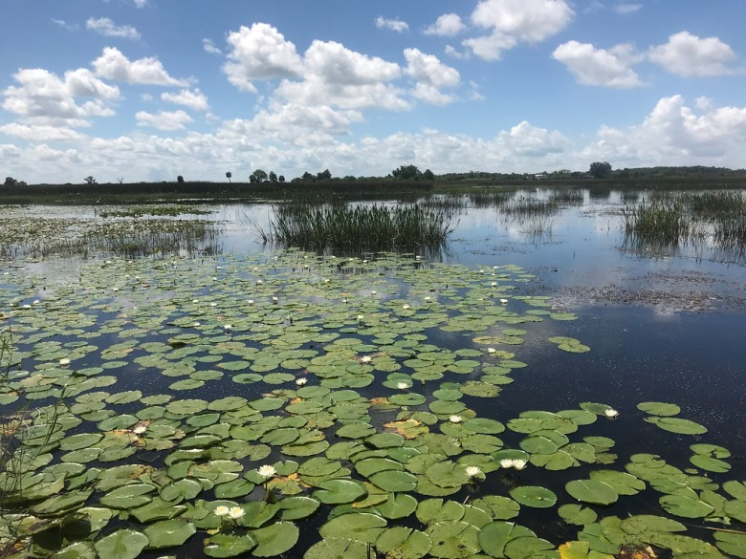
Covering just 2% of Earth’s surface, rivers, lakes, ponds and other freshwater habitats have higher animal species richness relative to area than either land or ocean habitats, report University of Arizona biologists in Ecology Letters. (Ecology Letters)

And finally…..

“The sun does not shine for a few trees and flowers, but for the wide world’s joy.”
Henry Ward Beecher

“Inward happiness almost always follows a kind action!”
Father Faber

“I cannot do all the good in the world, but the world needs all the good I can do.”
Jana Stanfield

See you in October!

Love and thanks,

Wen

